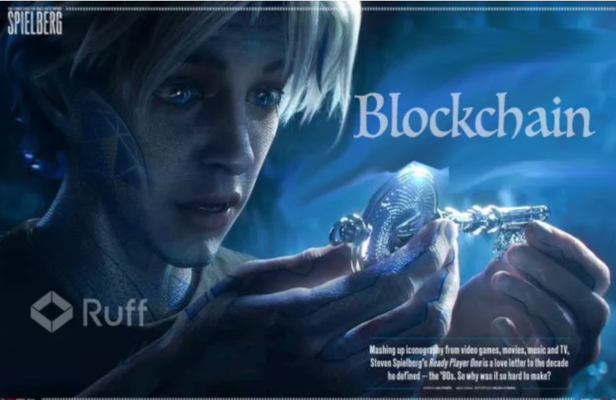

Maybe you are just like me, who spent over 2 hours in the cinema and managed to discover over 100 Easter eggs. Do you guys know that, the real biggest Easter egg in *Ready Player One* is actually blockchain!

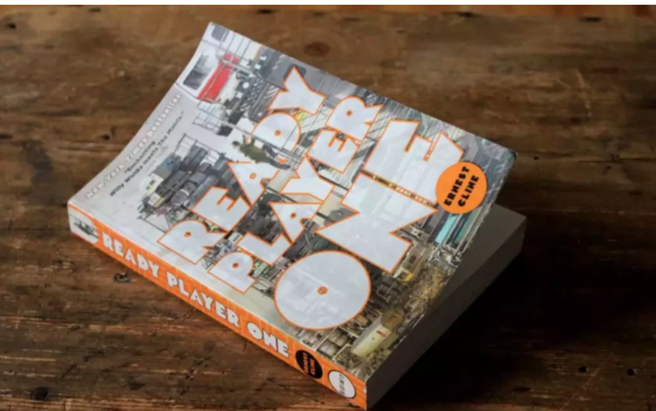

*Ready Player One* is a novel published by Ernest Cline in 2011, and he also participated in the production of this movie.

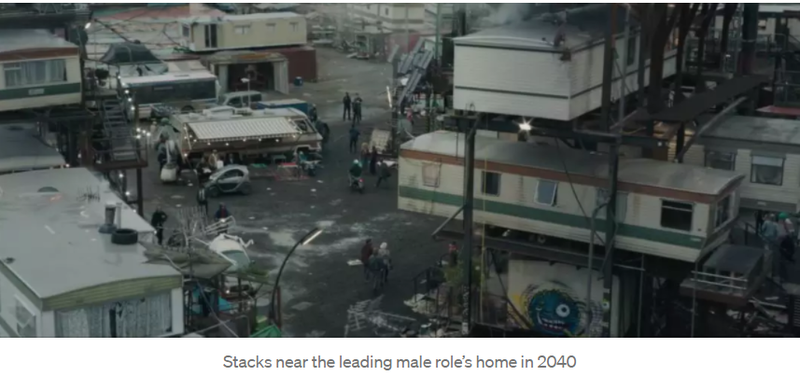

As its setting, in the year 2040, the world has been gripped by wards, pollution and energy crises. Seeing the disorder of the world and to escape the horrendous reality, people became immersed in a virtual reality game “OASIS”.

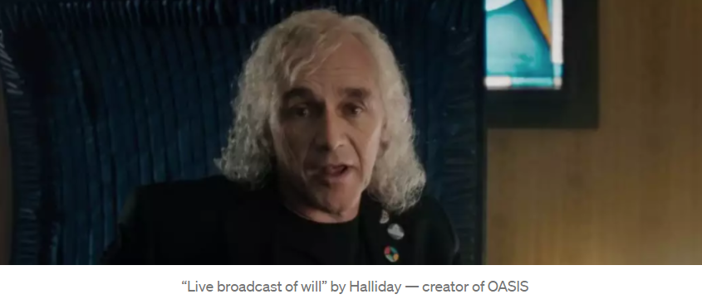

When he was to die, Halliday, the creator of OASIS, declared that, the winner of the egg hunt contest in the OASIS can inherit $500 billion along with a controlling stake in the OASIS.

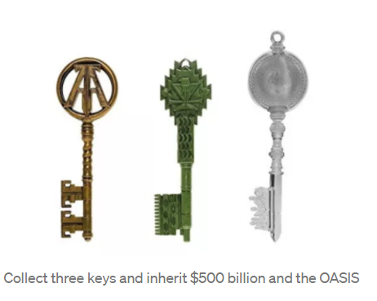

The rules of the game are: *complete challenges, collect 3 keys and open three gates*, and the first one to discover Halliday’s Easter egg will be the winner. Hearing such resounding news, all players wanted to win the game. A great many guys gave up after one year’s try. Till 5 years later, an average boy, Wade, as average as any one on the road, discovered the first key and instantaneously became “hot” in the OASIS. However, he didn’t realize that, this game had put him under crises and traps, as a matter of life and death.

This movie integrates a lot of popular elements in the 1970s, 1980s and 1990s from Japan, Europe to America, such as cartoons, movies and computer games. It has raised sympathy among many netizens, who have discovered over 100 Easter eggs in the movie. Some big boys even burst into tears when Daito was turned into Gundam at last.

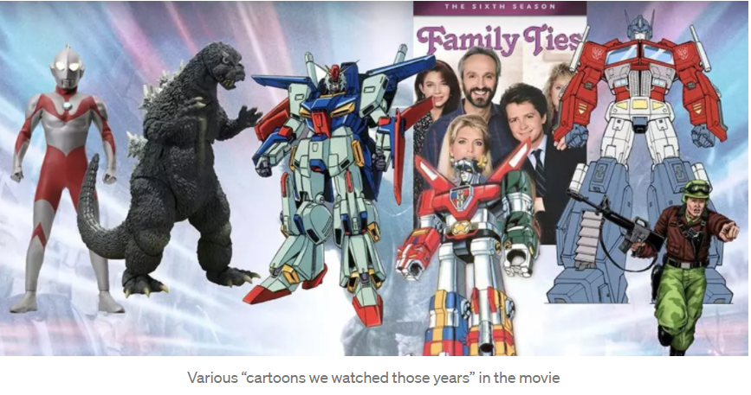

Apart from them, it also features tons of recent high techs: light-weighted, close-fitting and never-tiring VR goggles, face-recognition drone planes much smarter than cleaning robots, holographic projection display, transparent screen …

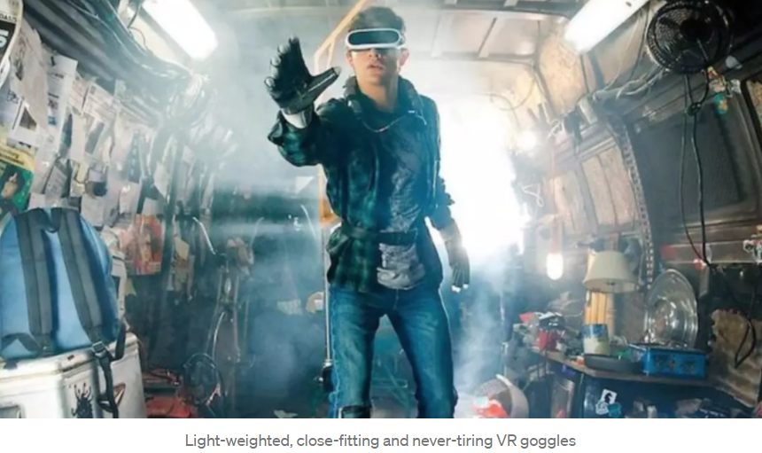

What’s cooler than all the above is that, smart foreigners discovered such a paragraph from the original novel and published it in the section of blockchain in a forum:

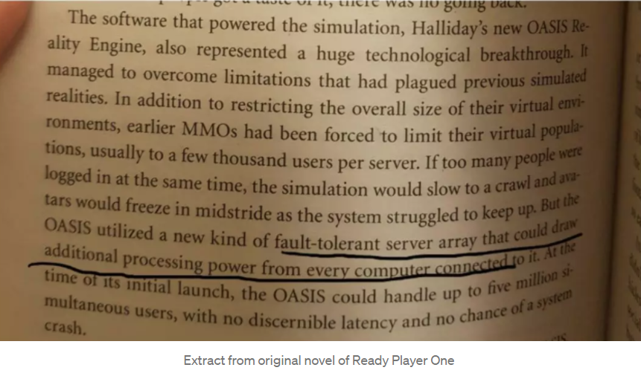

****Isn’t this the blockchain?****

OASIS-supported virtual technologies sound similar to the blockchain. The blockchain is with “fault tolerance” and is decentralized through different nodes connected in a distributed network, immutable. The more participants there are, the more stable the operation of OASIS will be.

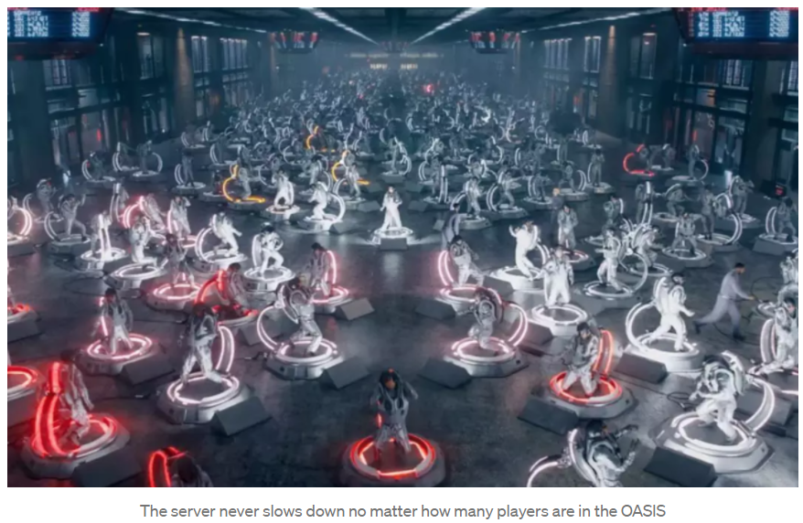

Some other signs also show that, blockchain technology is indispensable in this movie:

****⚪ Smart Contract⚪****

At first, it is most likely that, the founder of game — Halliday relies on smart contracts to guarantee the execution of “his will”. Smart contracts guarantee that his will can be executed, without any intervention from any centralized organization or other factors; only the man getting the egg can inherit his fortune and operate the OASIS.

All stage properties are developed according to the setting up in the game — when the villain took out his box-bottom treasure to bomb all the roles, the “life-saving gold coin” in Wade’s pocket has helped him survive alone. It’s not that this is the glory of leading male role, but that the setting of smart contract in the game can not be changed. It’s due to this setting that he survives, completes his mission and gets the keys and egg.

****⚪ Non-real name system⚪****

Blockchain is a technology, and virtual currency is the first successful application of blockchain. Everyone can register a “wallet”, and the major difference between the wallet and Alipay is: an Alipay account must be bound with an ID card or, at least, with a cellphone. And the boss of Alipay can know, if he likes, who transfers money to who and how much a person has. Nonetheless, a wallet does not correspond to a legal natural person. It only takes one minute to register a wallet, and one person can possess numerous wallets. Although the current amount in each wallet is open and transparent, you do not how many wallets a person has.It is for this reason that the government is unable to track the fund flow and cross-border remittance, and that’s also why some governments are unwilling to support citizens to use electronic currencies.

And, it’s also difficult to relate the figures in *Ready Player One* to the roles in the OASIS one by one; the villain can not relate Wade in the real world to the leading male role in the virtual world, till the leading male role’s head was turned by love, telling the leading female role in the OASIS “I’m Wade”. Later, when Wade meets game pals in the real world, they can recognize each other only through secret signs.

****⚪ Consensus Mechanism ⚪****

How can one get wealth in a virtual world? Roughly, there are mechanisms such as POW and POS.

POW (Proof of Work) means “the more you work, the more you earn”, while POS (Proof of Stake) means “the more you own, the more you earn, just like interest generated from bank deposits”.

Ordinary people arrested by IOI to work for it

The villain’s organization IOI arrests others under the name of “owing money”, who are made to continuously bury landmines and move bricks in the game, helping the villain to get the Easter egg. Isn’t this the consensus mechanism POW! Each node and everyone serving IOI pays off the debt with their own work; the more they do, the longer it takes, the more debt he pays off.

****⚪ Decentralization ⚪****

When Wade made a live broadcast and calls for all to help him find the egg, the villain once attempted to stop this broadcast and failed. Just like the “broadcast” in blockchain, everyone is enabled to listen to the same thing; each node records the same transaction in its own “ledger”. The logic is the same.

****⚪ Private keys should be written down on paper⚪****

I’m sure you remember such a scene: the villain’s hamster-ball is pasted with a sticky note, on which he writes down his password and allows the leading male and female roles to log into his account.

Those of you who have digital currencies must have an important booklet, on which there are mnemonics or passwords for wallets. Never record them in a computer, and, in particular, never transmit any of them via a chatting tool!! Otherwise, it’s likely that your digital assets may be stolen away, never to come back.

For more important knowledge on [Blockchain & IoT], you can read the following articles or visit the Ruff Chain community, and you’ll surely get what you want …

*[BTA Summit | Roy Li: Application Practice of Blockchain Technology at the Enterprise Level](https://medium.com/@ruffchain/bta-summit-ruff-founder-roy-li-application-practice-of-blockchain-technology-at-the-enterprise-3b1e5fde4d79)*

*Abstract: What is an Ethereum test network? Which consensus mechanism should be for public blockchain? Why is the iteration of blockchain technology more difficult than traditional technologies?*

*[Only Those Data with Value Flow and Value Circulation are Worth Going onto the Chain](https://medium.com/@ruffchain/ruff-chain-founder-roy-li-only-those-data-with-value-flow-and-value-circulation-are-worth-going-23adb2faf723)*

*Abstract: Should data go onto the cloud or chain? How are IoT and blockchain combined?*

Well, it’s possible that a game like the OASIS may come into being very soon, and, blockchain, for its features such as transparency, decentralization, and immutability, is bound to subvert our world in many fields such as science & technology, finance, law, life and medicine.

也许你和我一样，在电影院里呆了两个多小时，发现了 100 多个复活节彩蛋。你们知道吗，*Ready Player One*中最大的彩蛋其实是区块链！

*Ready Player One*是欧内斯特·克莱恩2011年出版的小说，他也参与了这部电影的制作。

作为它的背景，在 2040 年，世界已经被病房、污染和能源危机所笼罩。看到世界的无序，逃离可怕的现实，人们沉浸在虚拟现实游戏《绿洲》中。

OASIS 的创始人 Halliday 在临终前宣布，OASIS 寻蛋大赛的获胜者可以继承 5000 亿美元以及 OASIS 的控股权。

游戏规则为：*完成挑战，收集3把钥匙，打开三扇门*，第一个发现Halliday复活节彩蛋的人将获胜。听到如此响亮的消息，所有玩家都想赢得比赛。经过一年的尝试，很多人放弃了。直到 5 年后，一个普通的男孩韦德，和路上的任何人一样普通，发现了第一把钥匙，瞬间在 OASIS 中“炙手可热”。然而，他却没有意识到，这场比赛让他陷入了危机和陷阱，生死攸关。

这部电影融合了很多1970年代、1980年代和1990年代从日本、欧洲到美国的流行元素，如卡通、电影和电脑游戏。这引起了许多网友的同情，他们在电影中发现了100多个复活节彩蛋。当大东最终变成高达时，一些大男孩甚至泪流满面。

除此之外，它还拥有大量最新的高科技：轻巧、贴身、永不疲倦的VR护目镜、比清洁机器人智能得多的人脸识别无人机、全息投影显示、透明屏幕……

比以上更酷的是，聪明的老外从原著小说中发现了这样一段话，并在论坛区块链版块发表：

****这不是区块链吗？****

OASIS 支持的虚拟技术听起来类似于区块链。区块链具有“容错性”，通过连接在分布式网络中的不同节点去中心化，不可变。参与者越多，OASIS 的运行就越稳定。

其他一些迹象也表明，区块链技术在这部电影中是不可或缺的：

****⚪ 智能合约⚪****

一开始，很有可能是游戏创始人——Halliday依靠智能合约来保证“他的意志”的执行。智能合约保证他的意志可以被执行，无需任何中心化组织或其他因素的干预；只有得到鸡蛋的人才能继承他的财产并经营绿洲。

所有的舞台属性都是按照游戏中的设定来开发的——当反派拿出他的箱底宝物轰炸所有角色时，韦德口袋里的“救命金币”帮助他独自生存。这不是男主的荣耀，而是游戏中智能合约的设定是不能改变的。正是由于这种环境，他得以幸存下来，完成了他的任务并获得了钥匙和鸡蛋。

****⚪ 非实名制⚪****

区块链是一种技术，虚拟货币是区块链的第一个成功应用。每个人都可以注册一个“钱包”，而钱包和支付宝的主要区别在于：支付宝账户必须绑定身份证，或者至少绑定手机。而且支付宝的老板可以知道，如果他喜欢，谁给谁转账，一个人有多少钱。但是，钱包并不对应于法人自然人。注册一个钱包只需一分钟，一个人可以拥有无​​数个钱包。虽然目前每个钱包里的金额是公开透明的，但你不知道一个人有多少个钱包。正因如此，政府无法追踪资金流向和跨境汇款，这也是为什么有些政府对不愿支持公民使用电子货币。

而且，也很难将*Ready Player One*中的人物与OASIS 中的角色一一联系起来；反派无法将现实世界中的韦德与虚拟世界中的男主​​角联系起来，直到男主角被爱转过头来，告诉OASIS中的女主角“我是韦德”。后来，当韦德在现实世界中遇到游戏伙伴时，他们只能通过暗号认出对方。

****⚪共识机制⚪****

如何在虚拟世界中获得财富？大致有POW、POS等机制。

POW（Proof of Work）的意思是“你工作越多，你赚的越多”，而POS（Proof of Stake）的意思是“你拥有的越多，你赚的越多，就像银行存款产生的利息一样”。

被IOI逮捕为其工作的普通人

反派组织IOI以“欠钱”为名抓捕他人，让他们在游戏中不断地埋地雷、搬砖，帮助反派拿到彩蛋。这不就是共识机制POW吗！每个节点和每个服务于 IOI 的人都用自己的工作来还清债务；他们做得越多，花费的时间越长，他还清的债务就越多。

****⚪ 去中心化 ⚪****

当韦德直播并呼吁大家帮他寻找彩蛋时，反派曾试图阻止这场直播，但以失败告终。就像区块链中的“广播”一样，每个人都可以收听相同的东西；每个节点在自己的“账本”中记录相同的交易。逻辑是一样的。

****⚪ 私钥要写在纸上⚪****

相信大家还记得这样的场景：反派的仓鼠球上贴了一张便签，上面写下自己的密码，让男女主角登录自己的账号。

拥有数字货币的人一定有一本重要的小册子，上面有钱包的助记词或密码。切勿将它们记录在计算机中，尤其是切勿通过聊天工具传输它们中的任何一个！否则，您的数字资产很可能会被偷走，永远不会回来。